Abstract

This design project aims to create an inexpensive flood detection system to monitor rising water in remote locations or residential areas. The high water detection system divides into two parts: water sensing unit and data display unit. Both subsystems are based on the microcontroller Board and they are communicating wirelessly via Zigbee. Additionally, several custom-built modules, including water sensors, charging regulator, and status board, are designed to support moisture detection, power management, and information display. Flood prediction and warning aims to reduce risk of lives and economic impact. A flood alert system supports data collection, analysis, monitor and warning. Wireless sensor nodes are used to collect site information whereas a controller is used to analyse those collected site information and thereby generates flood warning.

Introduction

Due to rapid climate change in recent decades, an increase in the severity of flood-related damages is observed. This causes serious destruction to residential properties and it also threatens public safety, particularly residents in the coastal regions or in the areas with heavy rainfalls. Although several commercial flood warning systems are currently available, many of them are either expensive or unable to identify multiple water levels. In fact, some water detection devices are triggered by a single event and their alerts are broadcasted via a buzzer. However it is often too late for people to protect their belongings and evacuate to safe ground if their flood warning appliance is solely activated by a certain water level without pre-flood warning. The goal of this design project is to create a low-cost wireless high water detection system that senses rising water in real time and determines any potential flash floods. The current design includes water recognition system wirelessly transmitting sensor data to a receiver system using Zigbee.

In our project we used Fingerprint module for safety purpose. If user can match with this security then User can monitoring dam level and open gate door depending upon water level in dam. If any fake person try to match the fingerprint then buzzer will buzz also send information to receiver site someone fake person try to match fingerprint security. Transmitter send the data depending upon level of water .if water level greater than threshold level buzzer will buzz also send information to receiver & take action depending upon water level.

System Design

The flood detection system with Zigbee is divided into two parts, transmitter system and receiver system. They are crafted to address the following design considerations:

• Water sensors need to detect multiple water levels

• Sensor data can be transmitted and displayed via wireless medium

• A display module is required to show water levels and transmitter status in real time

• A high water warning indicator to inform user any flood risk

BLOCK DIAGRAM

Transmitter system

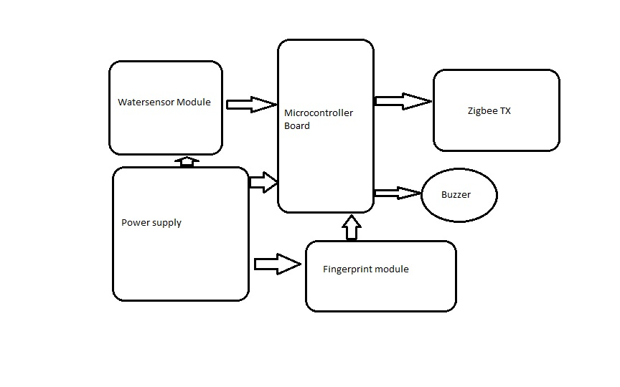

Receiver system

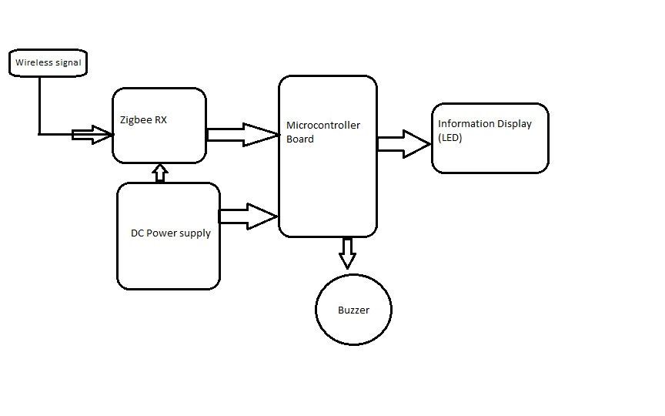

Working

In our project we used Fingerprint module for safety purpose. If user can match with this security then User can monitoring dam level and open gate door depending upon water level in dam. If any fake person try to match the fingerprint then buzzer will buzz also send information to receiver site someone fake person try to match fingerprint security. Transmitter send the data depending upon level of water .if water level greater than threshold level buzzer will buzz also send information to receiver & take action depending upon water level. A Zigbee transmitter system wirelessly sends water level data to a stationary receiver system. As water rises, the mounted sensors detect appropriate water level, then the transmitter system complies and relays raw data via a Zigbee module, and finally the receiver system interprets incoming data signal and displays real-time information on a dashboard.

To reduce maintenance requirement, the transmitter system utilizes a low-power microcontroller board, simple water detection circuits, fig shows the transmitter system flowchart. Simplicity and power saving are two key focuses in designing the transmitter system. Therefore, microcontroller is operating at the minimum clock speed and is directly transmitting raw data, gathered from water sensor module, to the receiver system.

Reliable data interpretation and real-time event notification are crucial to the receiver system design. Fig shows the receiver system flowchart. In this part, the receiver microcontroller board processes all incoming data and illuminates corresponding light emitting diodes (LEDs) on the information display board to report current water level and transmitter status. The flood warning module is activated when the system detects persistent high water level. Also, the receiver system automatically resets the display module as soon as water level recedes below the sensor line.

Software Design

Both Arduino microcontroller boards were programmed using the Arduino integrated development environment (IDE). Figure illustrates a regular Arduino IDE window Based on the C language, the Arduino IDE includes a variety of software libraries such as Ethernet and Wi-Fi. Additional software libraries can be easily imported as well. In this project, the software design strategy for the transmitter system is minimizing power consumption by

• Lowering the clock speed [8],

• Storing individual data into an array for easy transmission

• Forwarding raw data to the receiver system without excessive processing [13].

However the receiver system’s software design strategy uses the opposite approach. It implements several logical loops to ensure proper event notifications.

Advantage

* Minimal human interaction: Having minimum human interaction makes the possibility of having less interruption of the system.
* Operability in harsh environments: Sensor nodes, consisting of robust sensor design, integrated with high levels of fault tolerance can be deployed in harsh environments that make the sensor networks more effective.
* Easy to maintain

Application

1. Flood Monitoring

2. Environmental Observation and Forecasting

3. Disaster Prevention

4. Agricultural Management

5. Structure Health Monitoring

6. Habitat Monitoring

CONCLUSION

Wireless sensor Network nodes are used for flood measurements due to its tiny size and low power consumption. This paper is providing a solution to enhance the safety of the trains, automobiles at the bridges against flood water and avoid the loss to life and property. The wireless high water detection system is built to identify rising water levels and to warn any potential flood risk. The receiver system’s straightforward dashboard design gives user a fast update of current water level. This flood detection model is suitable for all outdoor and indoor applications, especially for locations without cell phone signal coverage.